Q3).. Step1🡪configure the snort

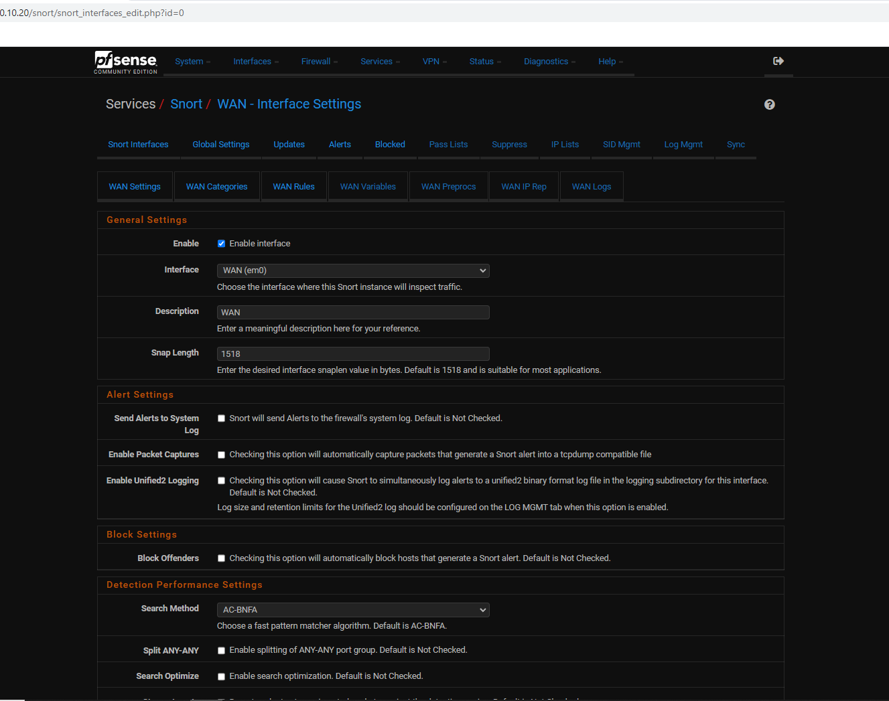

Step2🡪goto WAN rules and select category custum rules..and save it

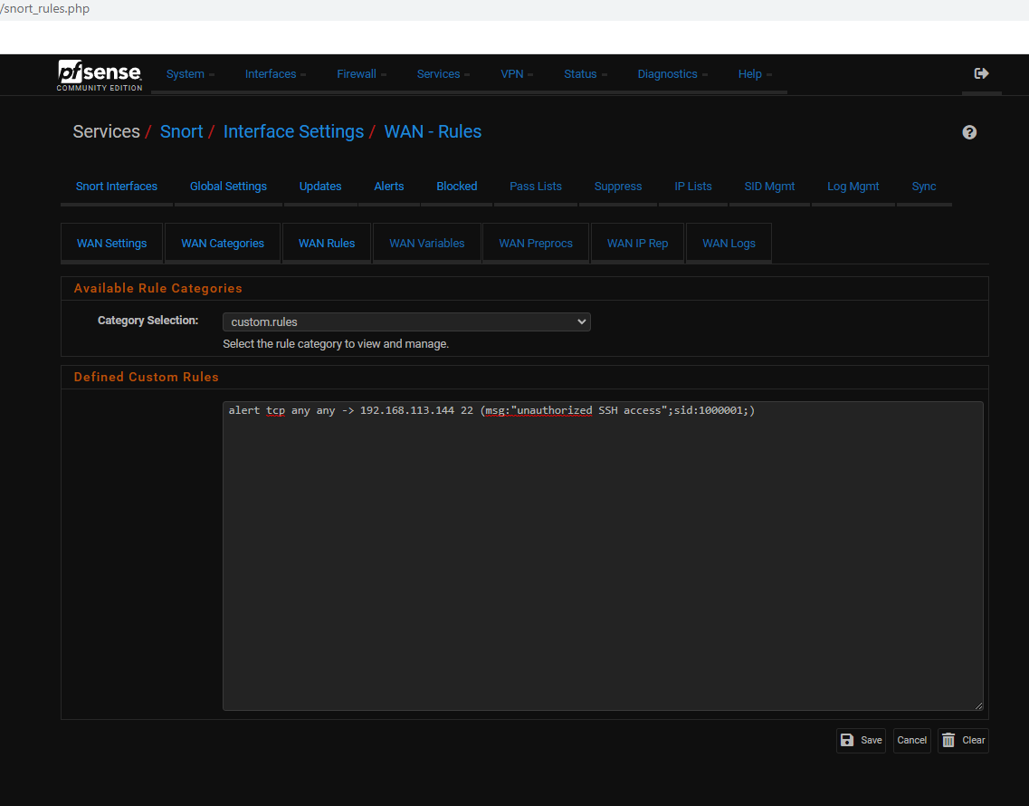

Step3🡪goto firewall NAT configuration and set the client ip to alerts msg

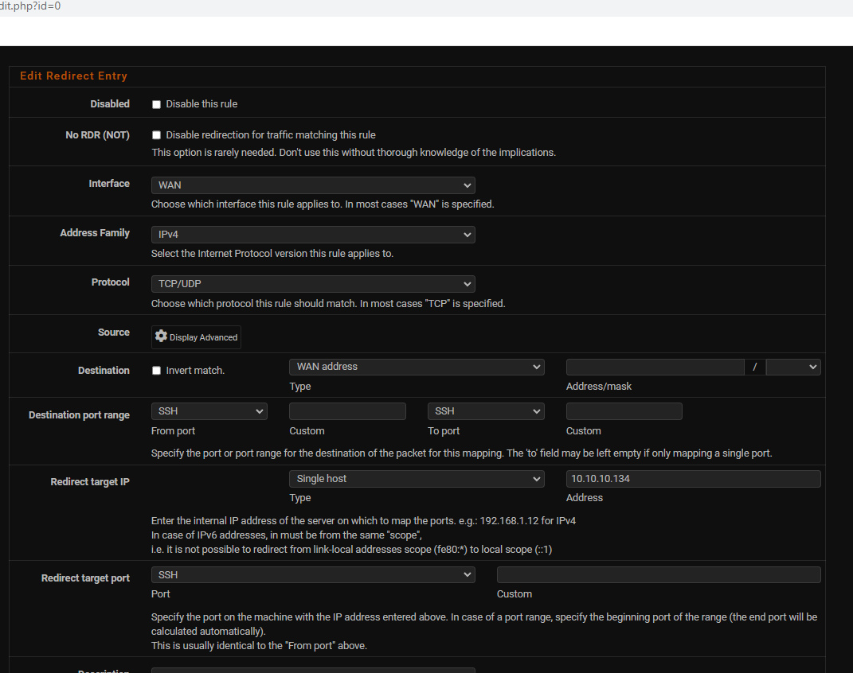

Step4🡪after config the firewall NAT then click on apply changes

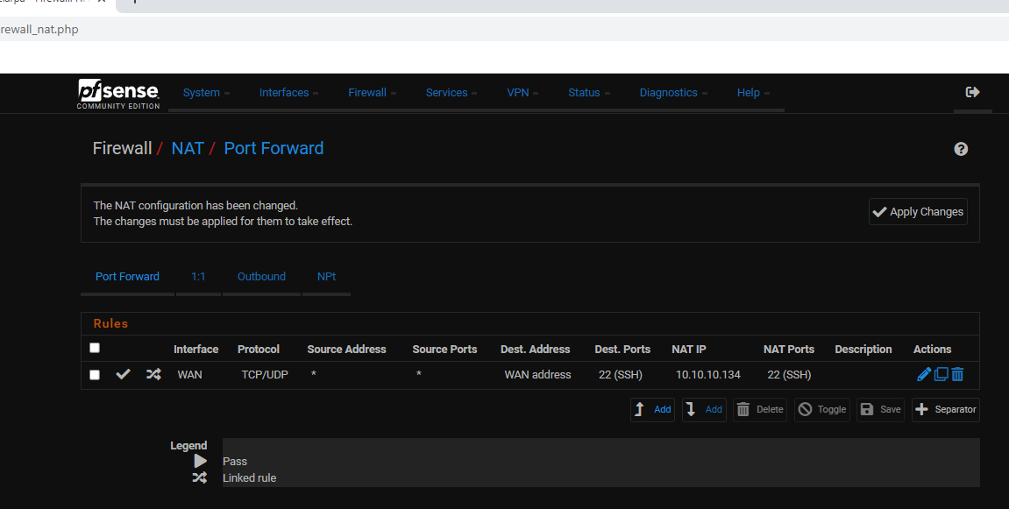

Step5🡪 the change s have been applied successfully

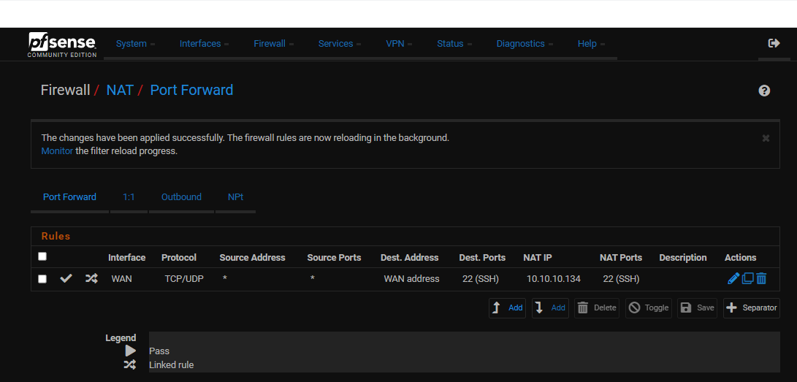

Step6🡪After all config are done then restart snort services

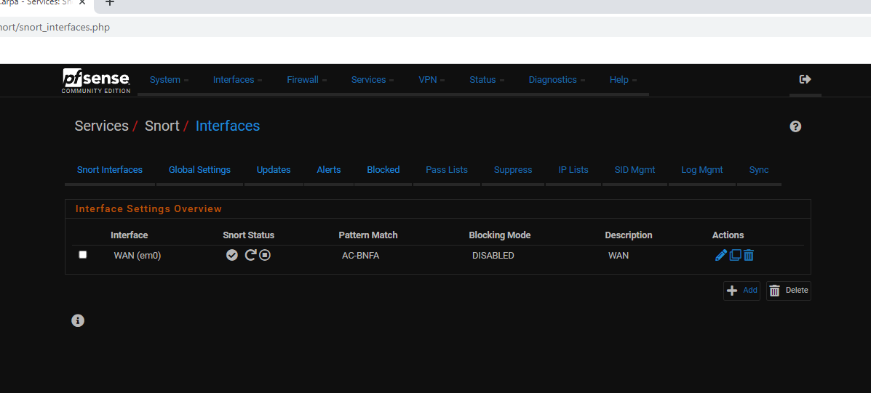

Step7🡪then goto another machine and ssh to pfsense NAT ip(192.168.113.144)

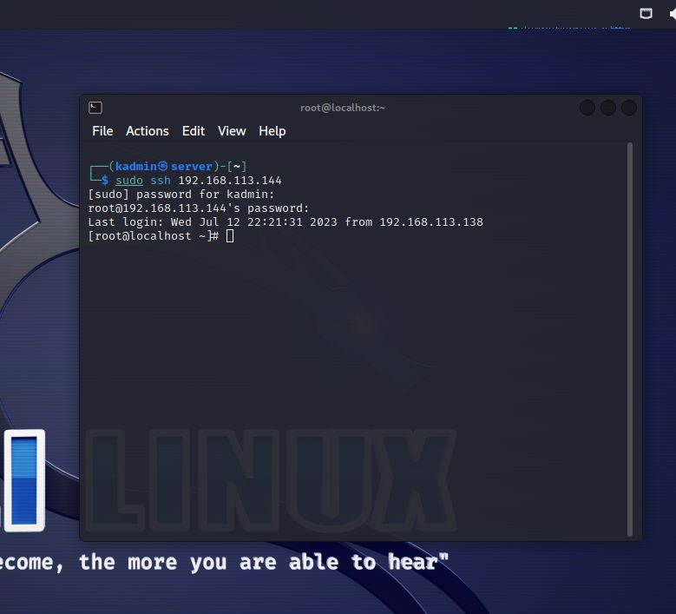

Step8🡪then goto alert tab in snort services and see the alert msgs “unauthorized SSH access”

